Press release

Palsgaard helps cake manufacturers crack high egg prices

Secrets of world-class bakery emulsifiers to be revealed at IBIE 2022

30 August 2022

Palsgaard is showcasing the power of its whipping-active emulsifiers to reduce the egg content of cake recipes – allowing significant cost reductions.

Earlier this year, wholesale egg prices in the US reached their second highest level ever, and with eggs accounting for as much as 30% of cake recipes, industrial bakers have been hit particularly hard. Solving this problem will be the focus of a Palsgaard knowledge-sharing session at the International Baking Industry Expo (IBIE) (September 18 to 21 in Las Vegas).

The amount of egg needed in a cake recipe depends largely on the choice of emulsifier. Traditional cake gels or hydrates, which are typically based on monoglycerides, can perform poorly on stability, meaning that more egg is needed.

Palsgaard® SA, a series of powdered emulsifiers for industrial baking, overcomes this challenge. Based on polyglycerol esters (PGEs) of fatty acids, it offers many functional properties, allowing egg content to be cut by an average of 20%. This translates to a typical cost reduction of around 5%.

Other Palsgaard knowledge sharing sessions at IBIE will showcase the performance benefits of its whipping-active emulsifiers, which also include the Emulpals® series for cake premixes. Visitors will be shown how the ingredients can help achieve the perfect shape, volume and crumb structure in cakes, as well as simplifying production and accelerating output.

Emulpals® and Palsgaard® SA are plant-based, sustainably sourced and produced in CO₂-neutral factories. They can also be used to create better-for-you cakes because they are free from trans fats and can allow a shift from saturated to unsaturated oils.

Sheila Rice, Business Development Manager at Palsgaard, said: “We’ve got decades of experience in the use of emulsifiers in baking – and we love sharing our knowledge. The beautiful thing about our whipping-active emulsifiers is that they solve such a wide range of challenges in cake production. Lower costs through reduced egg use is an obvious advantage, but there are so many performance benefits too. The proper emulsifier can be the key to the desired structure, volume and appearance of your cake, as well as providing the opportunity to create better-for-you recipes.”

Palsgaard will exhibit at IBIE at Booth #617 (West Hall). View the company’s new film, ‘How to make egg reduction a piece of cake’ at www.palsgaard.com/egg-reduction for more info.
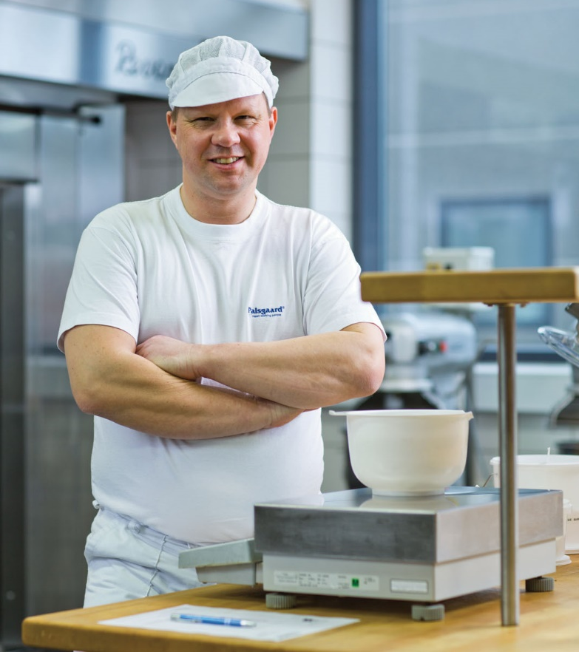
Photo: Senior Application Specialist Leif Jakobsen will host a series of knowledge-sharing sessions at Palsgaard’s booth at the IBIE, sharing his more than 20 years of experience working with cake emulsifiers

For more information or to arrange a media interview at IBIE contact:

Mette Dal Steffensen, Senior Brand Communications Specialist, Palsgaard A/S
mds@palsgaard.dk | +45 2073 4534

About Palsgaard
Emulsifier specialist Palsgaard helps the global food industry make the most of the ability to mix oil and water.
Thanks to the company’s specialized emulsifiers (and emulsifier/stabilizer systems), bakery, confectionery, condiments, dairy, ice cream, margarine and meat producers can improve the quality and extend the shelf-life of their products. Just as importantly, they can produce better-for-you products with improved taste, mouthfeel and texture while using less resources.
Since its founder Einar Viggo Schou invented the modern plant-based food emulsifier in 1917, Palsgaard has offered the industry know-how and innovation. From its six application centers around the world Palsgaard’s experienced food technologists help manufacturers optimize existing recipes and develop delicious products with better nutritional profiles.
Palsgaard helps manufacturers meet consumer and regulatory demands for greater responsibility, helping them grow and protect their brands. It is currently the world’s only commercial source of fully sustainable, emulsifiers based on RSPO SG-certified palm oil and produced by CO₂-neutral factories in Denmark, the Netherlands, Mexico, Brazil, China and Malaysia. The company’s products are non-GMO and meet halal and kosher requirements.
In addition to its food emulsifiers, Palsgaard supplies the polymers industry with a series of plant-based and food-grade polymer additives, which are particularly suited for preventing fogging and dust on plastic packaging.
Palsgaard is owned by the Schou Foundation and has 650+ employees across 17 countries. Its turnover in 2021 was 260 million USD (1.7 billion DKK) with products sold to more than 120 countries.

Reuters ‘Bird flu, Ukraine war push egg prices higher worldwide’, April 14 2022

